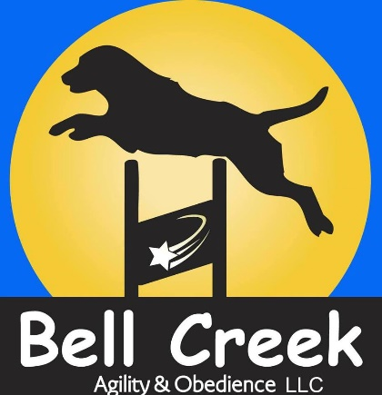
Bell Creek Agility & Obedience, LLC Board and Train Contract
Client & Dog Information
Owner’s Name:__________________ Referred by:______________
Home Phone: _________________ Work Phone:_____________
Cell Phone:___________________ Email:__________________
Address:______________________________________________________

Dog’s Name/ID:______________________ Breed:________________
Age:_______________ Sex:___________ Altered:__________

Emergency & Health Information
Emergency Contact:__________________ Phone:________________
Email:_____________________
Vet Practice:____________________ Vet’s Name:_________________
Phone Number:____________________
Current Medications:_____________________________________________
Reasons for Meds:______________________________________________
Known Allergies:________________________________________________

Feeding Schedule
Time(s):______________________________________________
Amount:______________________________________________
Type/brand of food:_____________________________________

Description of Services:
Description & dates of services:
Board & Train drop off date and pick up date:_____________________
Drop off location is 651 E Railroad Avenue unless alternate arrangements have been made.
Rate: $500 per week ($71.43 daily) with a minimum of a two week stay.

Training Goals:
- What sort of Lifestyle will you have with your dog (active, relaxed, city, rural)? ____________________________________________________________________________________________________________________________________________________________
- Are there any specific lifestyle adaptations that you would like your dog to handle?______________________________________________________________________________________________________________________________________________________
- Are there any behavior concerns you would like addressed?___________________________________________________________________________________________________________________________________________________
- Please list your top three training goals to be addressed during this period.
1.___________________________________________________________________________________________________________________________________________________________
2.___________________________________________________________________________________________________________________________________________________________
3.___________________________________________________________________________________________________________________________________________________________

Training Tools
Please initial if you authorize the use of: Will not be used on a puppy.
Prong Collar:_______________ Head Halter:________________
Vibration Bark Collar:_______________ E-Collar (provided by owner):____________

Liability Waiver & Policies
1. Bell Creek Agility & Obedience, LLC will endeavor to create as safe an environment as possible for the training and board of my dog and will offer only sound, safe, and responsible training and training instructions. However, I recognize that Bell Creek Agility & Obedience, LLC. is not responsible for any unintentional errors, omissions, or incorrect assertions. I understand that the recommendation of any product or service is not a guarantee of my satisfaction with that product or service. Further, I am and will remain responsible for the actions of my dog at all times and I hereby agree to indemnify and hold harmless Bell Creek Agility & Obedience, LLC of any and all claims of injury, expense, costs, or damages caused by the actions of my dog while under Bell Creek Agility & Obedience, LLC, instruction or control and under my own care as a result of following training instructions. I have been told by Bell Creek Agility & Obedience, LLC and understand the inherent risks of owning a dog, including but not limited to the risk of dog bites to myself or others.
2. I authorize Emergency medical care to be provided for my dog by Tier 1 Veterinary Hospital (Wasilla), Midnight Sun Veterinary Services (Anchorage), or an appropriate alternate to be determined by Bell Creek Agility & Obedience, LLC in the event that the regular veterinarian is not available or that closer care is required. I understand I am responsible for any and all veterinary costs and agree to reimburse Bell Creek Agility & Obedience, LLC, for any charges related to emergency care.
3. I authorize Bell Creek Agility & Obedience, LLC, to administer and seek First Aid and resuscitative care for my dog as determined appropriate by Bell Creek Agility & Obedience, LLC and I agree to indemnify and hold harmless Bell Creek Agility & Obedience, LLC, for any and all results thereof.
4. I understand that all dogs will be boarded at owner’s home address of 2010 Terrebonne Loop, Anchorage, AK 99502. Owner gives Bell Creek Agility & Obedience, it’s owners, trainers, permission to travel back and forth from our main location to boarding location as well as permission to offsite locations for additional training. They further understand the inherent risks associated with transportation such as, but not limited to, loss or injury due to accident; owner agrees to assume all risks and financial costs associated with said transportation. Dogs will be crated during transportation.
5. I understand that my dogs will be trained using primarily positive reinforcement methods. If corrective tools are used, they I have initialed permission above for them to aid in the training of my dog. I also understand that although my dogs will learn multiple behaviors, basic obedience, new routines, and management while in the care of Bell Creek Agility & Obedience, LLC, it is my responsibility to maintain this learning upon their return to the home environment. Dogs do not generalize well. This means that behavior taught while in our care will only be solidified through clear, calm and consistent repetition once home. Bell Creek Agility & Obedience, LLC recommends owners commitment to continued education through group classes and private instruction to proof and generalize training.
6. Animal behavior is never fixed or static; it changes depending on circumstance and environment. Even trained behaviors will fade or extinguish over time without consistent repetition and practice. Especially in cases of fear or aggression, although behavior may be modified, the dog is never “cured”. A dog’s behavior is ultimately the responsibility of the owner
This contract is validated by the signatures below in total and as approval for future services without additional authorization:
Dog Guardian:_____________________ Date:_________________
Trainer:_________________________ Date:______________________

