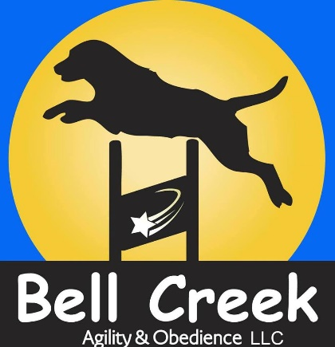
Bell Creek Agility & Obedience, LLC Board and Train Contract
Client & Dog Information
Owner’s Name:__________________ Referred by:______________
Home Phone: _________________ Work Phone:_____________
Cell Phone:___________________ Email:__________________
Address:______________________________________________________

Dog’s Name/ID:______________________ Breed:________________
Age:_______________ Sex:___________ Altered:__________

Emergency & Health Information
Emergency Contact:__________________ Phone:________________
Email:_____________________
Vet Practice:____________________ Vet’s Name:_________________
Phone Number:____________________
Current Medications:_____________________________________________
Reasons for Meds:______________________________________________
Known Allergies:________________________________________________

Feeding Schedule
Time(s):______________________________________________
Amount:______________________________________________
Type/brand of food:_____________________________________

Description of Services:
Description & dates of services:
Boarding drop off date and pick up date:_____________________
Drop off location is 651 E Railroad Avenue unless alternate arrangements have been made.
Rate: $35 dollars daily unless student/prior client in which case it is $30 dollars daily.

Known commands:
______________________________________________________________________________________________________________________________________________________________________________________________________

For general care during walking and kenneling
Please initial if you authorize the use of:
Prong Collar:_______________ Head Halter:________________
Vibration Bark Collar:_______________ E-Collar (provided by owner):____________

Liability Waiver & Policies
1. Bell Creek Agility & Obedience, LLC will endeavor to create as safe an environment as possible for boarding of my dog and will offer only sound, safe, and responsible care. However, I recognize that Bell Creek Agility & Obedience, LLC. is not responsible for any unintentional errors, omissions, or incorrect assertions. I understand that the recommendation of any product or service is not a guarantee of my satisfaction with that product or service. Further, I am and will remain responsible for the actions of my dog at all times and I hereby agree to indemnify and hold harmless Bell Creek Agility & Obedience, LLC of any and all claims of injury, expense, costs, or damages caused by the actions of my dog while under Bell Creek Agility & Obedience, LLC, instruction or control and under my own care as a result of following training instructions. I have been told by Bell Creek Agility & Obedience, LLC and understand the inherent risks of owning a dog, including but not limited to the risk of dog bites to myself or others.
2. I authorize Emergency medical care to be provided for my dog by Tier 1 Veterinary Hospital (Wasilla), Midnight Sun Veterinary Services (Anchorage), or an appropriate alternate to be determined by Bell Creek Agility & Obedience, LLC in the event that the regular veterinarian is not available or that closer care is required. I understand I am responsible for any and all veterinary costs and agree to reimburse Bell Creek Agility & Obedience, LLC, for any charges related to emergency care.
3. I authorize Bell Creek Agility & Obedience, LLC, to administer and seek First Aid and resuscitative care for my dog as determined appropriate by Bell Creek Agility & Obedience, LLC and I agree to indemnify and hold harmless Bell Creek Agility & Obedience, LLC, for any and all results thereof.
4. I understand that all dogs will be boarded at the trainer’s home. Owner gives Bell Creek Agility & Obedience, it’s owners, trainers, permission to travel back and forth from our main location to boarding location as well as permission to offsite locations for work and . They further understand the inherent risks associated with transportation such as, but not limited to, loss or injury due to accident; owner agrees to assume all risks and financial costs associated with said transportation. Dogs will be crated during transportation.

This contract is validated by the signatures below in total and as approval for future services without additional authorization:
Dog Guardian:_____________________ Date:_________________
Trainer:_________________________ Date:______________________

